Experiment No. 2

#include <stdio.h>
int main() {
int a[10][10], b[10][10], result[10][10];
int i, j, k, r1, c1, r2, c2;

printf("Enter rows and columns of first matrix: ");
scanf("%d %d", &r1, &c1);

printf("Enter rows and columns of second matrix: ");
scanf("%d %d", &r2, &c2);

printf("\nEnter elements of first matrix:\n");
for(i = 0; i < r1; i++)
for(j = 0; j < c1; j++)
scanf("%d", &a[i][j]);

printf("\nEnter elements of second matrix:\n");
for(i = 0; i < r2; i++)
for(j = 0; j < c2; j++)
scanf("%d", &b[i][j]);

// ADDITION
printf("\n--- Matrix Addition ---\n");
if(r1 == r2 && c1 == c2) {
for(i = 0; i < r1; i++) {
for(j = 0; j < c1; j++) {
result[i][j] = a[i][j] + b[i][j];
printf("%d ", result[i][j]);
}
printf("\n");
}
} else {
printf("Addition not possible.\n");
}

// SUBTRACTION
printf("\n--- Matrix Subtraction ---\n");
if(r1 == r2 && c1 == c2) {
for(i = 0; i < r1; i++) {
for(j = 0; j < c1; j++) {
result[i][j] = a[i][j] - b[i][j];
printf("%d ", result[i][j]);
}
printf("\n");
}
} else {
printf("Subtraction not possible.\n");
}

// MULTIPLICATION
printf("\n--- Matrix Multiplication ---\n");
if(c1 == r2) {
for(i = 0; i < r1; i++) {
for(j = 0; j < c2; j++) {
result[i][j] = 0;
for(k = 0; k < c1; k++) {
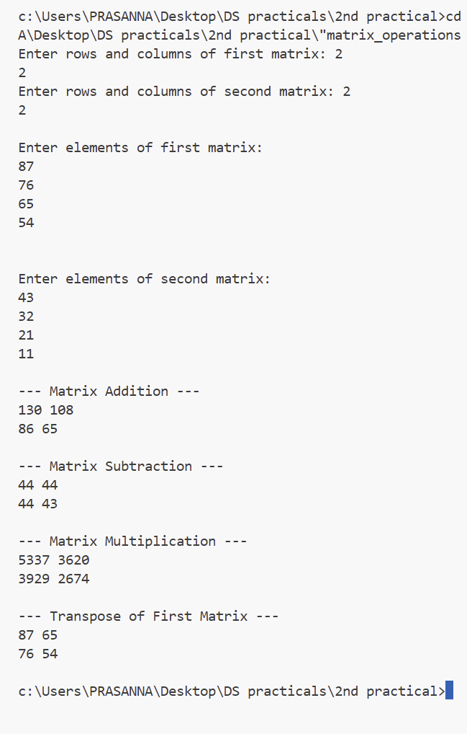
result[i][j] += a[i][k] * b[k][j];
}
printf("%d ", result[i][j]);
}
printf("\n");
}
} else {
printf("Multiplication not possible.\n");
}

// TRANSPOSE OF FIRST MATRIX
printf("\n--- Transpose of First Matrix ---\n");
for(i = 0; i < c1; i++) {
for(j = 0; j < r1; j++) {
printf("%d ", a[j][i]);
}
printf("\n");
}

return 0;
}

